PATCHING ACTIVITY From 19.3.0 to 19.15.0
- First check the alert log file
We have to check the alert log file; there we get the any error then resolve it first.
Find out the alert log file location name:
find /u01 -name alert*.log

- Take the full database backup with rman
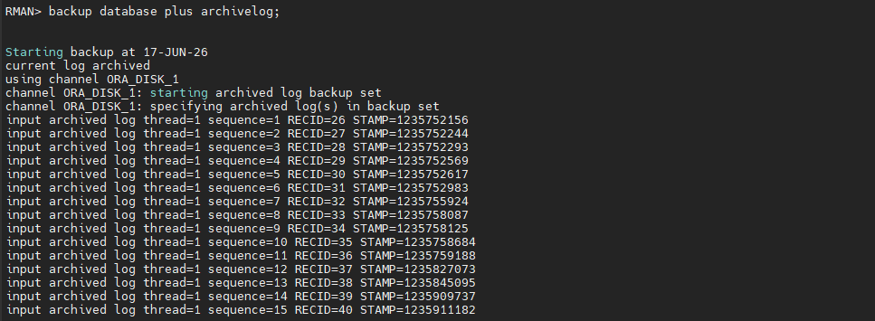
- Check the backup details its completed or not
Set lin 200 pages 200
COL START_TIME FOR A20
COL END_TIME FOR A20
select SESSION_KEY, INPUT_TYPE, STATUS,
to_char(START_TIME,'mm/dd/yy hh24:mi') start_time,
to_char(END_TIME,'mm/dd/yy hh24:mi') end_time,
elapsed_seconds/3600 hrs from V$RMAN_BACKUP_JOB_DETAILS
order by session_key;
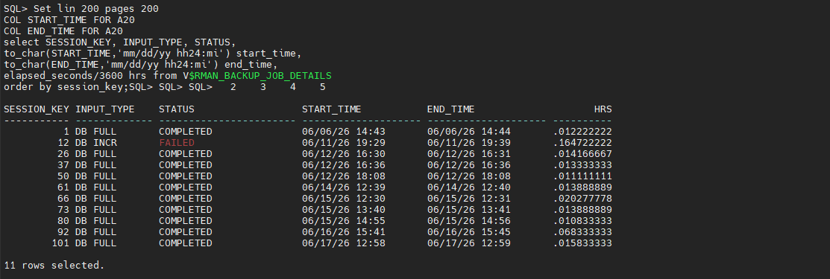
- Check any invalid objects
SELECT COUNT(*) AS invalid_count FROM all_objects WHERE status = 'INVALID';
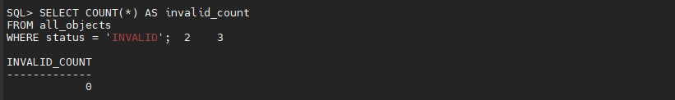
If the invalid object is present then run the below query
SQL> @?/rdbms/admin/utlrp.sql
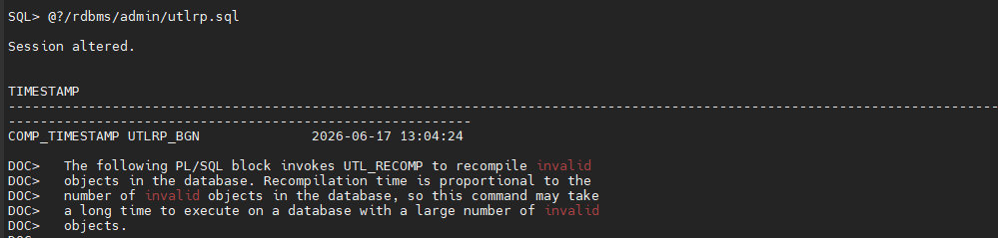
- Check database version
SQL> select banner_full from v$version;
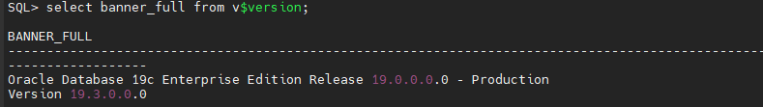

- Check OPatch version
cd $ORACLE_HOME/OPatch
./opatch version
- Check OPatch inventory
Cd $ORACLE_HOME/OPatch
./opatch lsinventory
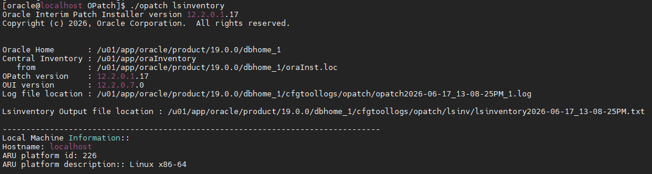
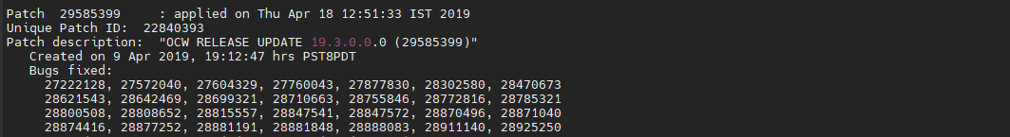
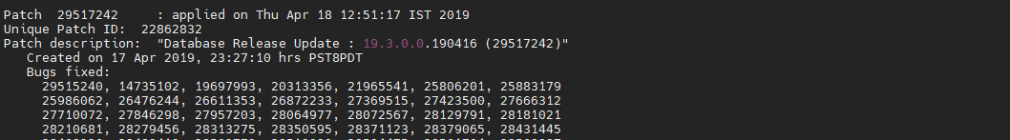
- Check the last patches
./opatch lspatches

- Check the ‘dba_registry_sqlpatch’
SELECT PATCH_ID,PATCH_TYPE,ACTION,STATUS,ACTION_TIME,DESCRIPTION FROM DBA_REGISTRY_SQLPATCH ORDER BY ACTION_TIME;
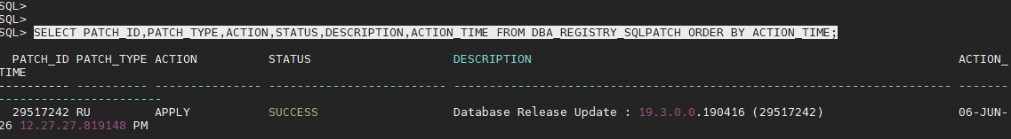
- FRA SIZE CHECK
The using size is 3.1877 gb. Now I will increase the size in following step:
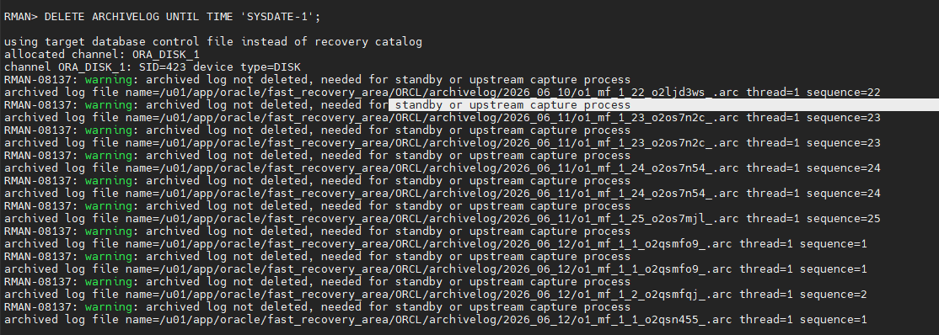
- Check the opatch conflict
$ORACLE_HOME/OPatch/opatch prereq CheckConflictAgainstOHWithDetail -phBaseDir /u02/33859214/33803476/33806152
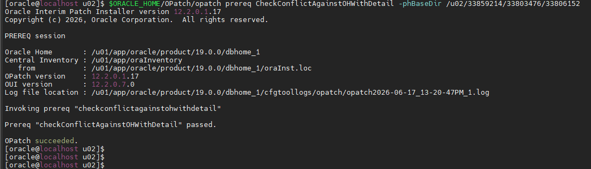
$ORACLE_HOME/OPatch/opatch prereq CheckConflictAgainstOHWithDetail -phBaseDir /u02/33859214/33803476/33815596
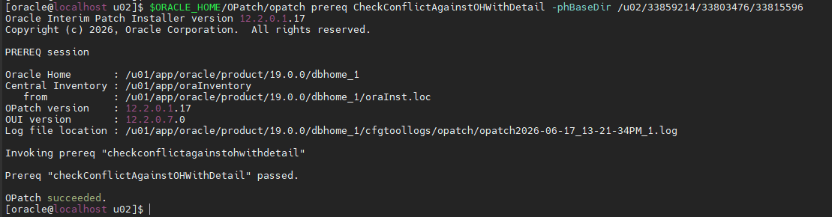

- Create a text file in patching location
Now inside /u02/33859214 we have to create this path using VI editor.
/u02/33859214/33803476/33806152
/u02/33859214/33803476/33815596

- We have to shutdown the DB with listener and confirmed it.
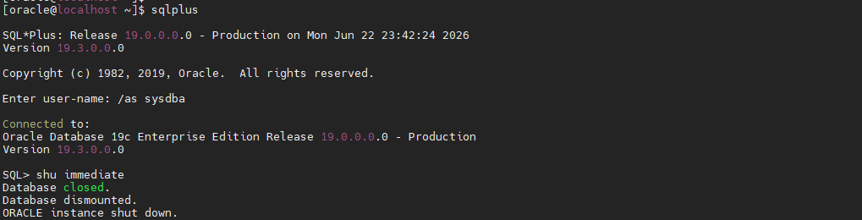
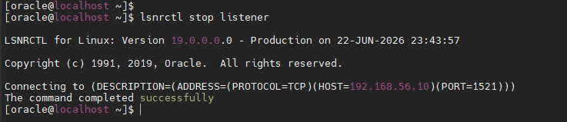
- Now we have to go that directory path and type ‘opatch apply’, its showing command not found.
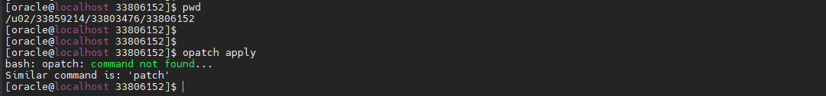
The error is coming because the opatch is not present in /u02 location. It’s present in the oracle home location.
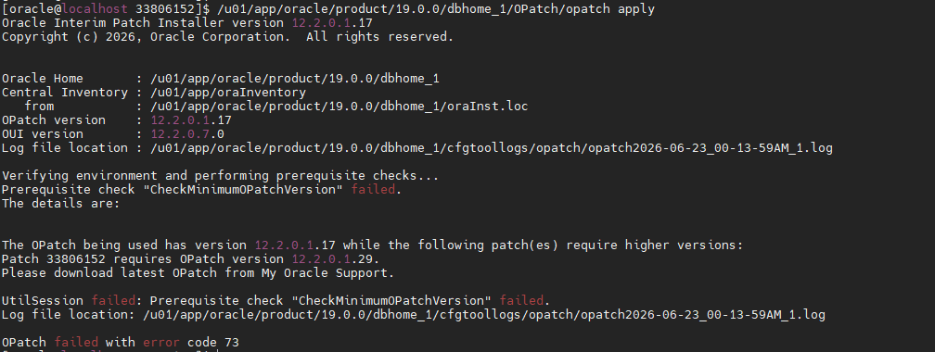
My opatch version is 12.2.0.1.17 but the version is required “Patch 33806152 requires OPatch version 12.2.0.1.29.”

- Upgrade the opatch utility
Backup OPatch
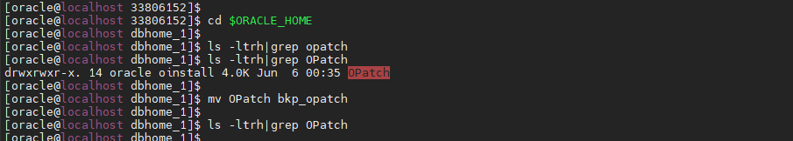
Now the opatch version is updated
Then run opatch apply again error is coming.
- As we know no binaries not be usable inside the /u01 during patching activity else it will fail.
- But here some files inside the oracle_home still executed by some session hence our DB is down.
- So we have to find out that session and killed that for our activity.

- For checking which activity is running command:
lsof | grep "/u01/app/oracle/product/19.0.0/dbhome_1"
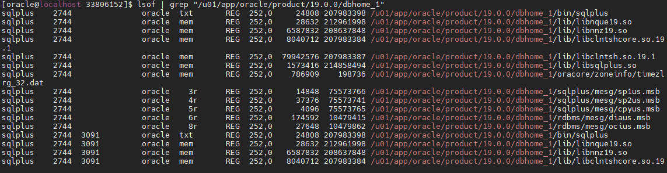
- Now kill the session
Kill the session and no processes are running.
- Now run opatch apply
But the error is coming. Its space issue.
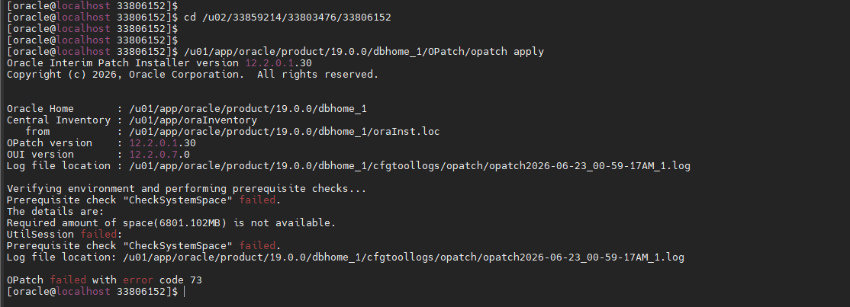
Solve the disk space issue in /u01 location, after that apply the opatch apply tools.
[root@localhost 33806152]# /u01/app/oracle/product/19.0.0/dbhome_1/OPatch/opatch apply
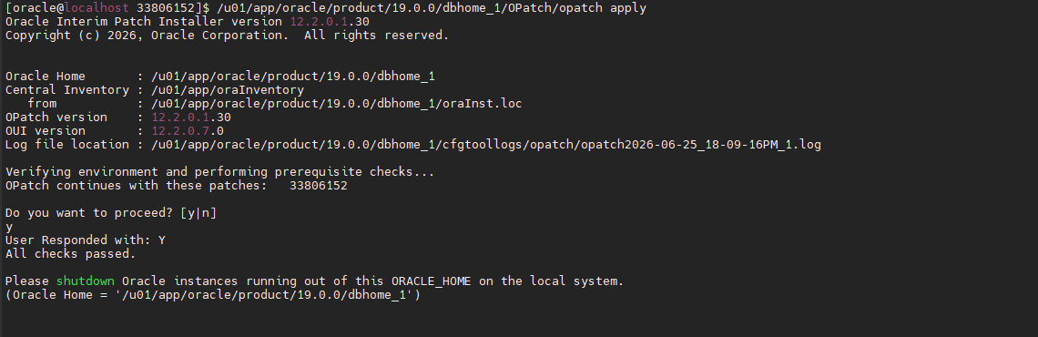
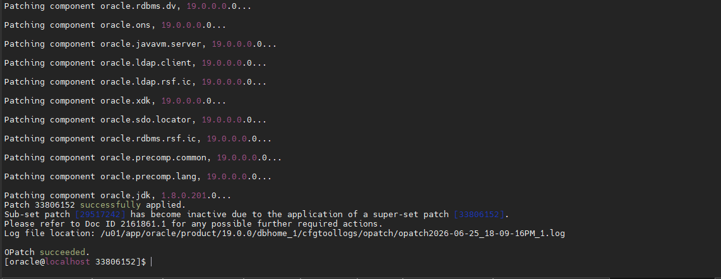
- START THE DATABASE AND LISTENER
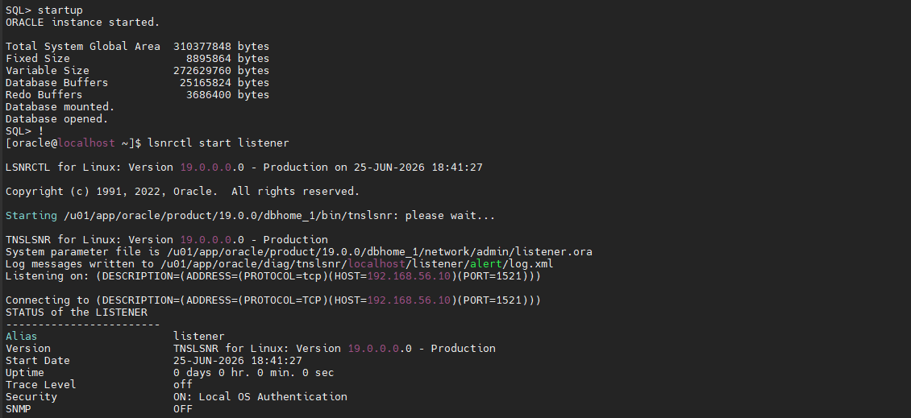
- Check the patch details in db layer.
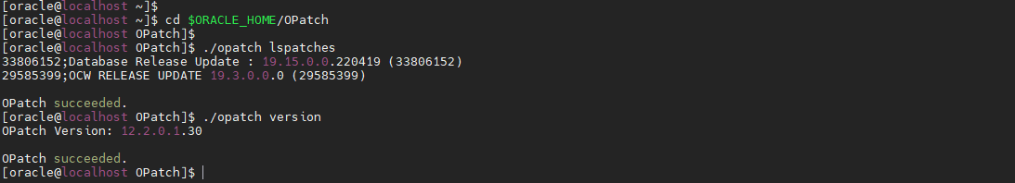

- Check the sql prompt checking patch
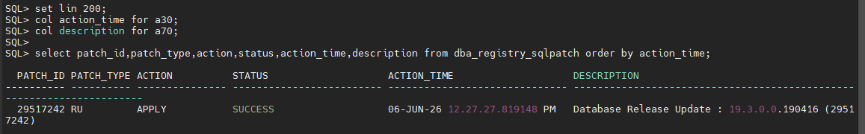
But the patch version is old patch version. So we need to run datapatch -verbose.
- Run the datapatch -verbose
